**Data Structures**

* It is a data organization , management and storage format that enables efficient access and modification.
* Or , a data-structure is a particular way of organizing data in a computer so that it can be effectively used .

**Abstract data types**

* It is made up of primitive data-types , but operation logics are hidden
* Special kind of data-types whose behavior is defined by a set of values and set of instructions.
* Ex :- Lists , stack , queue

**Linked lists**

Types of linked lists

1. Singly Linked list
2. Doubly Linked list
3. Circular Linked list

Each type will consist at least following functions to operate on the list-elements

* Create – to create the list (Although , one can create a simple list directly in the main function without any user-defined function)
* InsertAtHead – To insert the element at the beginning of the list
* InsertAtPos – To insert the node at specific position
* InsertAtTail – to insert at the last
* DeleteHead
* DeleteTail
* DeleteElement – Delete the node with specific data
* Reverse
* Traverse – to go through the nodes in order to operate them or print them

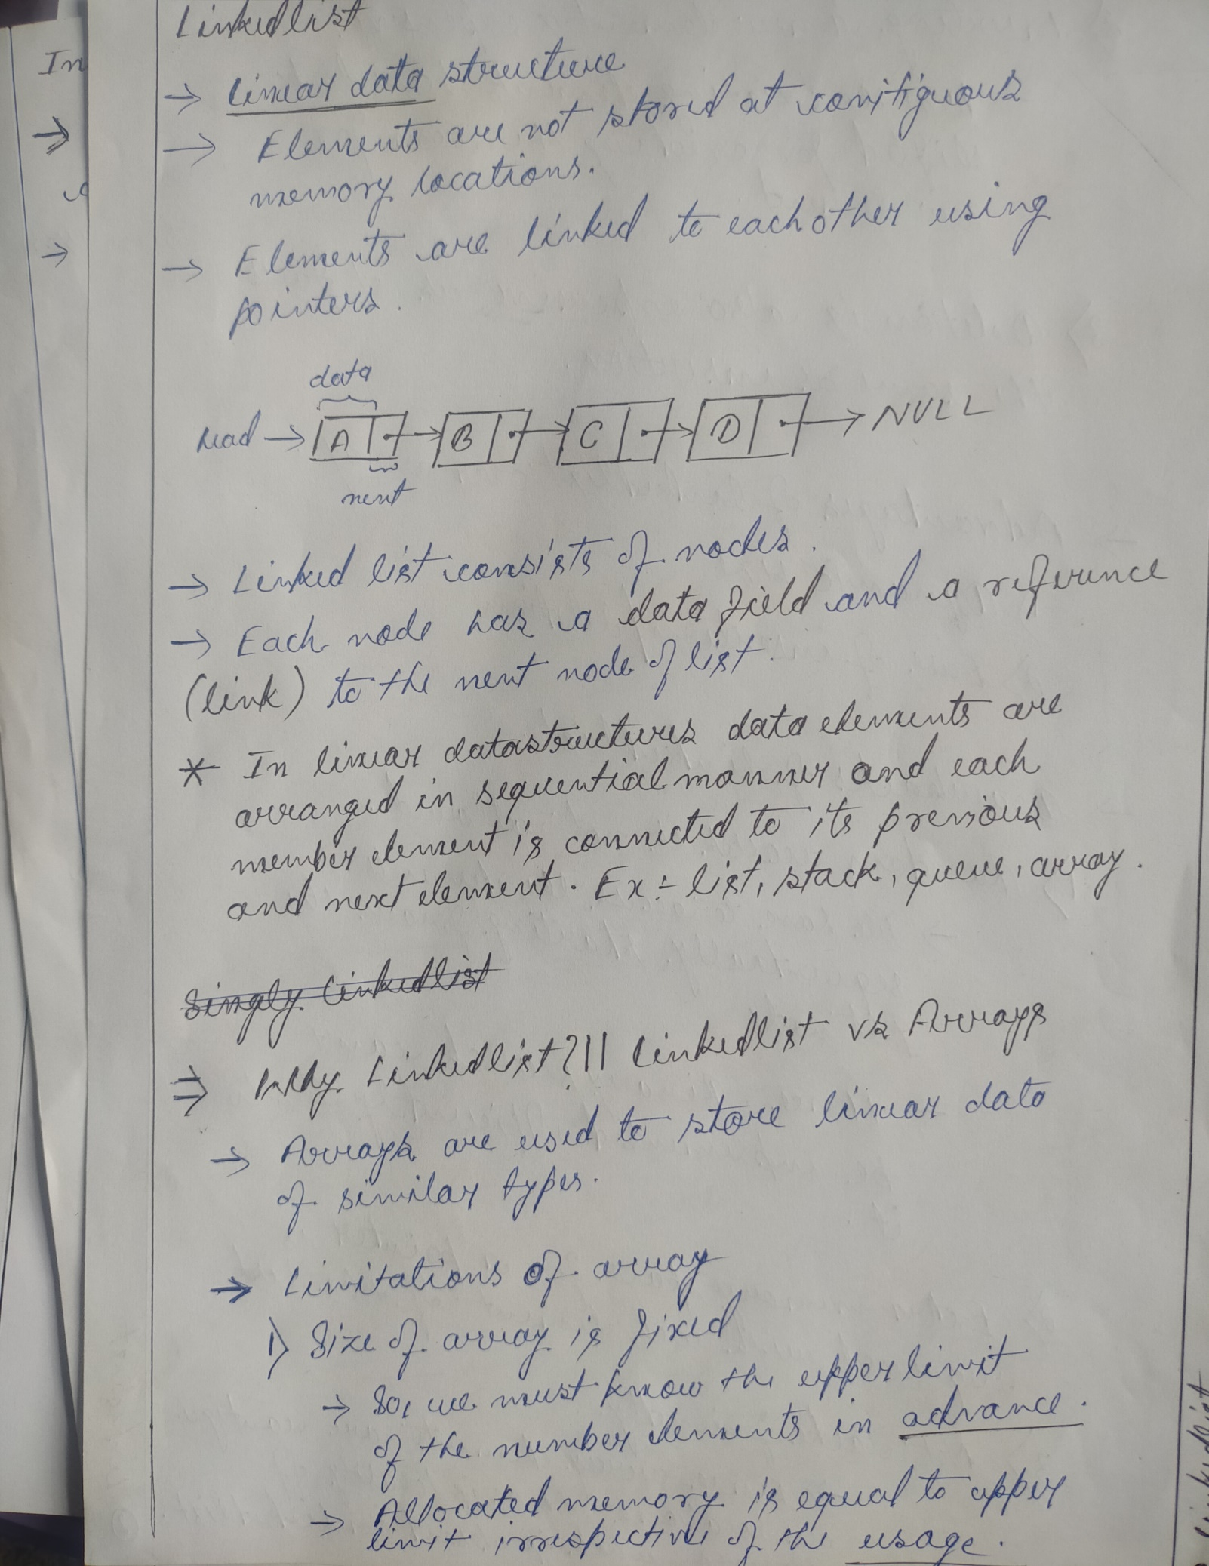

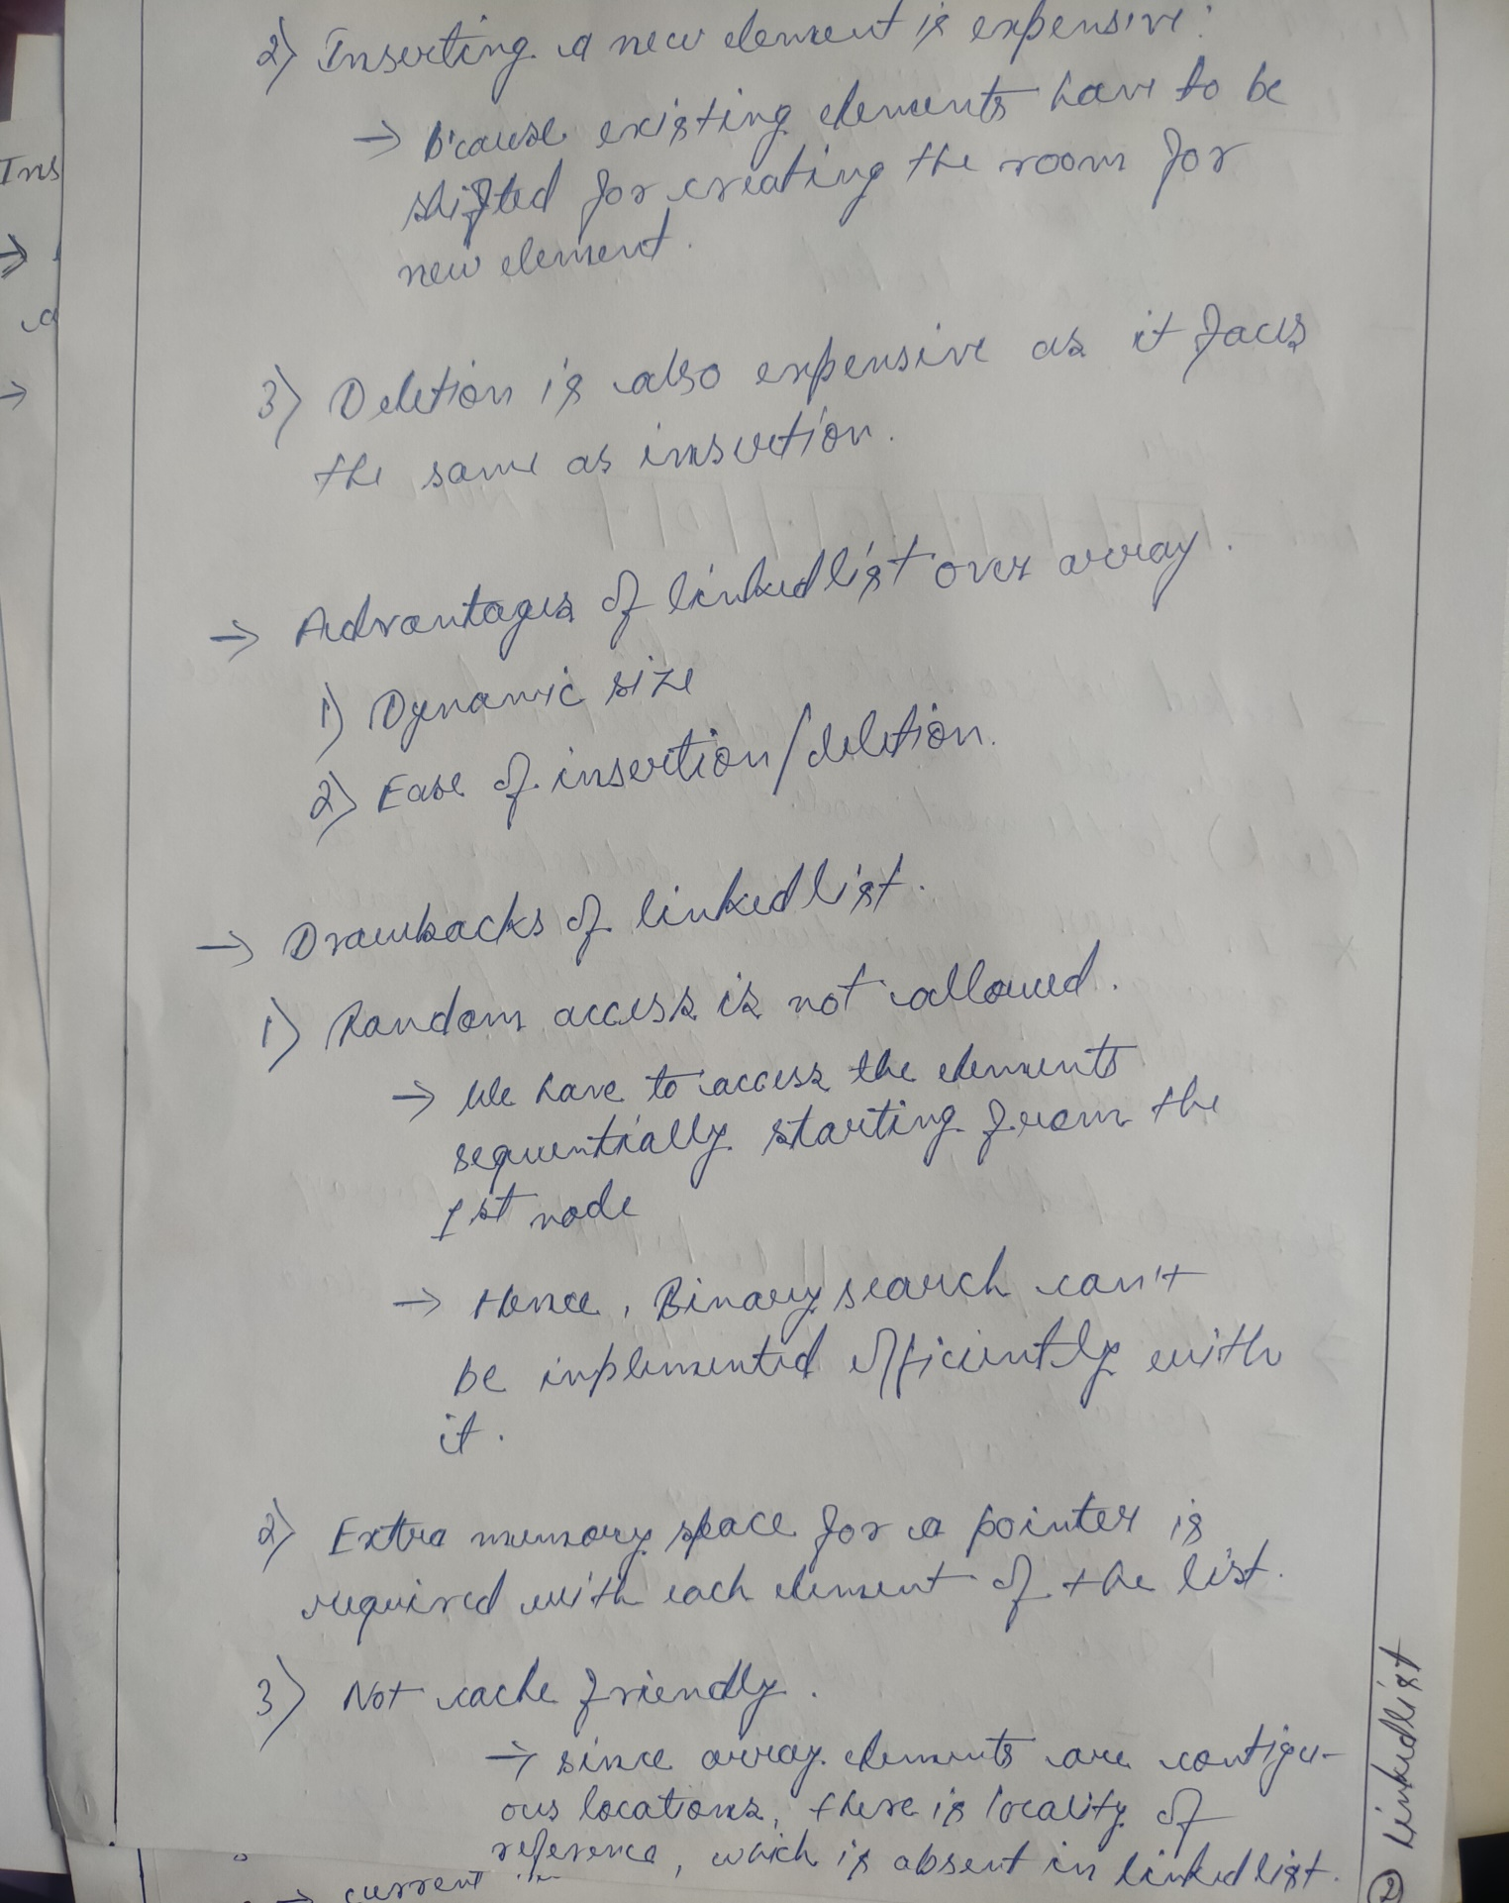

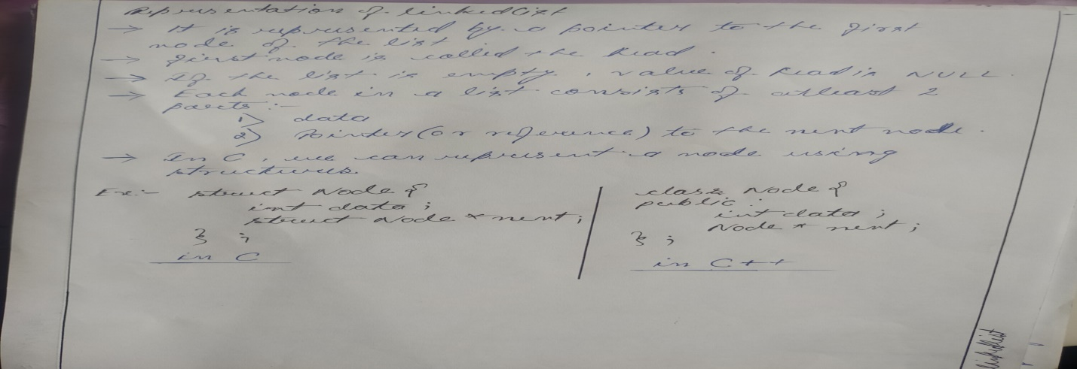

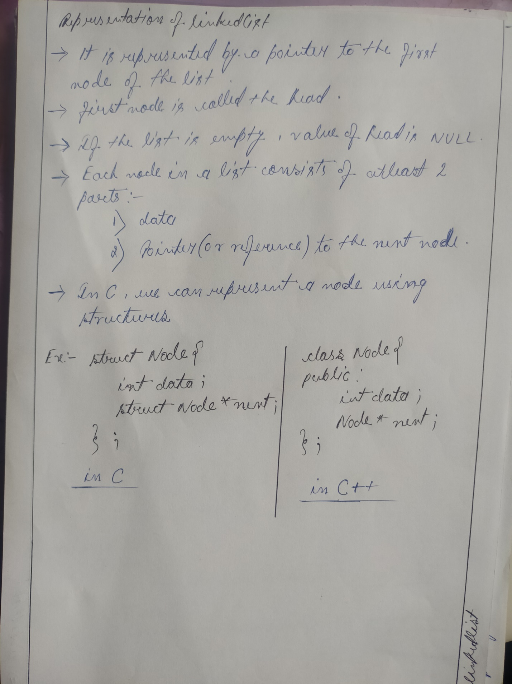

*- Array is a single block of memory with partition while Linked list is a multiple blocks of memory linked to each other .*

**Singly Linked list**

* It is the standard type of linkedlist , in which there are two fields in each element one is data and another one is next node pointer .
* Unlike doubly linked list , this is an one-way list .

***typedef struct node{***

***int info ;***

***struct node * next ;***

***We can create a list without a specific create() function also , i.e with insertAtTail() function .***

***}node;***

**Algorithm create(head , n)**

input : head – pointer to the first node of the list (*initially head = NULL*)

n – number of nodes/elements in the list

1 . if head != NULL then

2 . print(“List is already created”)

3 . return

4 . end if

5 . for i <- 1 to n do

6 . input item

7 . newnode <- getNode()

8 . info[newnode] <- item

9 . next[newnode] <- NULL

10 . if head = NULL then

11 . head <- newnode

12 . else

13 . next[temp] <- newnode

14 . temp <- newnode

15 . end for

16 . return

**void create(node ** head , int n) Time-comp : O(n)**

{

node * newnode , * temp ;

int item , i ;

if(*head!= NULL)

{

printf(“List created\n”);

return ;

}

for(i=1 ; i<=n ; i++)

{

printf(“Enter item = ”);

scanf(“%d”,&item);

newnode=(node*)

malloc(sizeof(node));

newnode -> info = item ;

newnode -> next = NULL ;

if((*head)==NULL)

(*head) = newnode ;

else

temp -> next = newnode ;

temp = newnode ;

}

return ;

}

**void insertAtHead(node ** head , int item)**

Here , head is being/might get modified , hence ***head is passed by reference*** ,instead of value , by double pointer .

Same concept is used in deletion and reverse of the list .

{

if((*head) == NULL)

{

Time-complexity : O(1)

printf(“List Empty\n”);

return;

**/*We can create a list in this block only , by assigning head to newnode*/**

}

node * newnode = (node*)malloc(sizeof(node));

newnode -> info = item ;

**In CPP , we create a node by using class and constructors in it ,**

**class node{**

**int data ;**

**node * next ;**

(constructor is optional ; it is used to create a node instantly , instead manually)

**node(int val){**

**data = val ;**

**next = NULL ;**

**}**

**};**

**node* newnode = new node(data) ; 🡨 Node creation in CPP**

newnode -> next = *head

(*head) = newnode ;

return;

}

**void insertAtTail(node**head , int item)**

{

if((*head) == NULL)

{

printf(“List is empty\n”);

return ;

**/*We can create a list in**

**this block only ,**

**by assigning head to newnode*/**

}

node * newnode = (node * )malloc(sizeof(node));

newnode->info = item ;

newnode -> next = NULL ;

Time-complexity : O(n)

Can be optimized to O(1) : GFG

node * loc = *head ;

while(loc->next!=NULL)

loc = loc->next ;

loc->next = newnode ;

return ;

}

**void traverse(node*head)**

Time-complexity : O(n)

{

if(head==NULL)

{

printf(“List is empty\n”);

return ;

}

node * temp = head ;

while(temp!=NULL)

{

printf(“%d ” , temp->info);

temp = temp->next ;

}

return;

}

**int search(node * head , int key)**

{

if(head == NULL)

{

printf(“List is empty\n”);

Time-complexity : O(n)

Worst case :

Best case :

return 0;

}

node * temp = head ;

while(temp!=NULL)

{

if(temp->info == key)

return 1;

temp = temp->next ;

}

return 0 ;

}

**void insertAtPos(node**head , int pos , int item)**

{

if(*head == NULL)

{

Time-complexity : O(n)

Can be optimized to O(1) : GFG

printf(“List is empty\n”);

return ;

}

node *loc , *newnode ;

loc = *head ;

int totalnode = 0 , currentnode ;

while(loc != NULL)

{

totalnode = totalnode + 1 ;

loc = loc -> next ;

}

if(pos > totalnode + 1||pos<=0)

{

printf(“Your element is not there\n”);

return ;

}

currentnode = 1 ;

loc = *head ;

while(currentnode < pos-1 && loc!=NULL)

{

currentnode +=1 ;

loc = loc->next ;

}

node * newnode = (node*)malloc(sizeof(node));

newnode->info = item ;

if(pos == 1)

{

newnode->next = *head ;

*head = newnode ;

}

else{

newnode->next = loc->next ;

loc->next = newnode ;

}

return ;

}

**int deleteHead(node ** head )**

{

if(*head = NULL)

{

printf(“The list is empty\n”);

return -9999;

}

node * temp = *head ;

int val = (*head)->info ;

*head = *head->next ;

temp->next = NULL;

In CPP , instead of **free()** function to delete a node , we use **delete** function . e. g **delete temp ;**

free(temp);

return val;

}

**void deleteTail(node**head)**

{

if(*head == NULL)

{

printf(“List is empty\n”);

return ;

}

node *loc , *locp ;

loc = *head ;

locp = NULL ;

while(loc->next!=NULL)

{

locp = loc ;

loc = loc->next;

}

printf(“%d is deleted \n” , loc->info);

if(loc==*head)

*head = loc->next;

else

locp->next = loc->next;

free(loc);

return;

}

**void deleteElement(node**head , int key)**

Elements can be deleted by specific position also and for this head to doubly linked list

{

if(*head == NULL)

{

printf(“List is empty\n”);

return ;

}

node * loc , *locp ;

loc = *head ;

locp = NULL ;

while(loc!=NULL && loc->info!=key)

{

locp = loc ;

loc = loc -> next ;

}

if(loc==NULL)

{

printf(“%d is not in the list\n”,key);

return ;

}

else if(loc == (*head))

*head = loc->next ;

else

locp->next = loc->next ;

loc ->next = NULL ;

free(loc);

return ;

}

**void reverse(node**head)** *(Iterative method)*

Time-complexity : O(n)

{

if(*head==NULL || *head->next ==NULL)

{

printf(“The list is empty or it has only single node\n”);

return ;

}

**node *pre , *curr , *nex ;**

pre = NULL ;

curr = (*head) ;

while(loc!=NULL)

{

nex = curr->next ;

curr->next = pre ;

pre = curr ;

curr = nex ;

}

*head = pre ;

return ;

}

**node * reverse(node *head)** (***recursive method)***

{

if(head==NULL || head->next ==NULL)

Time-complexity : O(n)

return head ;

node * newhead = reverse(head->next);

head->next->next = head ;

head->next = NULL ;

In this function head value is not gonna change , hence we can call the function by value , hence **head is not required

return newhead ;

}

**void insertAfter(node*head , int data , int pos)**

{

/*Is to finish: head to **GFG**\*/

}

**Doubly Linked list**

- Each node contains an extra data-field which occupies an extra pointer which holds the address of the previous node .

- The previous pointer of the first node will point over NULL

*Representation of Node in a DLL*

***typedef struct node{***

***int info ;***

***struct node * next ;***

***struct node * prev ;***

***}node;***

*Advantages Of DLL over Singly Linked List:-*

- A DLL can be traversed in both forward and backward direction

- Deletion of node in a DLL by the given address/pointer is possible

- We can quickly insert a new node before a given node : In singly linked list to insert a node , pointer of the previous node is needed , which is accessed by traversal . But , In DLL we can get the previous node using previous pointer .

*Disadvantages Of DLL over Singly Linked List:-*

- Each node of DLL require extra space for a previous pointer **(DLL with single pointer is possible : head to GFG)**

- Insertion and Deletion operations require an extra pointer *prevoius* to be maintained which results 1 or 2 extra operations/steps leading to longer time .

**void create(node **head , int n)**

{

if((*head)!=NULL)

{

printf(“Already created\n”);

return ;

}

*Time-complexity : O(n)*

int i , item;

node *newnode , *temp ;

for(i=1;i<=n;i++)

{

printf(“Enter the item = ”);

scanf(“%d”,&item);

newnode = (node*)malloc(sizeof(node));

newnode->info = item ;

newnode->next = NULL;

if(*head==NULL)

{

*head = newnode ;

newnode->prev = NULL ;

}

else

{

temp->next = newnode ;

newnode->prev = temp ;

}

temp = newnode ;

}

return ;

}

**void traverse(node*head)**

{

if(head==NULL)

{

printf(“List is empty\n”);

return ;

}

node *loc , *current ;

*Time-complexity : O(n)*

loc = head ;

while(loc!=NULL)

{

printf(“%d”,loc->info);

current = loc ;

loc = loc->next ;

}

loc = current ;

while(loc!=NULL)

{

printf(“%d”,loc->info);

loc = loc->prev ;

}

return ;

}

**void insertAtHead(node**head , int item)**

{

if(*head == NULL)

*Time-complexity : O(1)*

{

printf(“List is empty\n”);

return;

}

node * newnode = (node*)malloc(sizeof(node));

newnode->info = item ;

newnode->next = (*head) ;

newnode->prev = NULL ;

*head->prev = newnode ;

*head = newnode ;

return ;

}

**void insertAtTail(node*head , int item)**

{

if(head==NULL)

{

printf(“List is empty\n”);

return ;

}

node *newnode , *temp ;

*Time-complexity : O(n)*

temp = head ;

while(temp->next != NULL)

{

temp = temp->next;

}

newnode = (node*)malloc(sizeof(node));

temp->next = newnode ;

newnode->next = NULL;

newnode->prev = temp ;

return ;

}

**void insertAtPosition(node**head , int data , int pos)**

{

if(*head == NULL)

*Time-complexity(Worst case) : O(n)*

*Best-case : O(1)*

{

printf(“List is empty”);

return ;

}

node *loc , *newnode ;

int totalNode , currentNode ;

totalNode = 0 ;

loc = *head ;

while(loc!=NULL)

{

totalNode++ ;

loc = loc->next ;

}

if(pos<=0 || pos > totalNode+1)

{

printf(“Invalid position entered\n”);

return ;

}

newnode = (node*)malloc(sizeof(node));

newnode->info = data ;

loc = *head ;

currentNode = 1 ;

while(currentNode < pos – 1 && loc!=NULL)

{

loc = loc->next ;

currentNode++;

}

if(pos==1)

{

newnode->next = *head ;

newnode->prev = NULL ;

( *head )->prev = newnode ;

( *head) = newnode ;

}

else

{

newnode->next = loc->next ;

newnode->next->prev = newnode ;

newnode->prev = loc ;

loc->next = newnode ;

}

return ;

}

**void insertAfter(node**head , int data , int pos) /* FINISH THESE : HEAD TO GFG */**

**void insertBefore(node **head , int data , int pos)**

**int deleteHead(node**head)**

{

if(*head == NULL)

*Time-complexity : O(1)*

{

printf(“List is empty\n”);

return -9999 ;

}

node * temp = *head ;

int deletedData = temp->info;

*head = *head->next ;

*head->prev = NULL ;

temp->next = NULL ;

free(temp) ;

return deletedData;

}

**int deleteTail(node**head)**

{

if(*head == NULL)

{

printf(“List is Empty\n”);

return -9999;

*Time-complexity : O(n)*

}

node * temp = *head ;

while(temp->next!=NULL)

{

temp = temp->next ;

}

int deletedData = temp->info ;

if(temp==*head)

*head = temp->next ;

else

{

temp->prev->next = temp->next ;

temp->prev = NULL ;

}

free(temp) ;

return deletedData ;

Elements can be deleted by specific data/key also and for this head to singly linked list

}

**int deleteAtPos(node**head , int pos)**

{

if(*head == NULL)

{

printf(“List is empty\n”);

return ;

}

int deletedData , count;

node * temp ;

if(pos==1)

deletedData = deleteHead(head); <-**OR one can write whole delethead() function here**

else

{

temp = *head ;

count = 1 ;

while(temp!=NULL && count != pos)

{

temp=temp->next;

count++ ;

}

if(temp==NULL) {

printf(“Invalid Position\n”);

return ;

}

deletedData = temp->info ;

temp->prev->next = temp->next ; // last node deletion is covered by this statement only

if(temp->next!=NULL)

temp->next->prev = temp->prev ;

temp->next = temp->prev = NULL ;

free(temp);

}

return deletedData ;

}

**int deleteAtPos(node**head , int pos)**

**{**

**if(*head == NULL)**

**{**

**cout << "List is empty" <<endl ;**

**return -9999 ;**

**}**

**int item , count ;**

**node *temp = (*head);**

**if(pos == 1)**

**{**

**item = (*head)->data ;**

**\*head = (*head)->next ;**

**(*head)->prev = NULL ;**

**}**

**else**

**{**

**count = 1 ;**

**while(temp!=NULL && count!=pos)**

**{**

**temp = temp->next ;**

**count ++ ;**

**}**

**if(temp==NULL) {**

**printf(“Invalid Position\n”);**

**return ;**

**}**

**item = temp->data ;**

**temp->prev->next = temp->next ;**

**if(temp->next!=NULL)**

**temp->next->prev = temp->prev ;**

**temp->next = temp->prev = NULL ;**

**}**

**delete temp ;**

**return item ;**

**}**

**Another way to write the deleteAtPos() function**

**Circular Linked list**

- There is no NULL at the end .

- next of last node is pointing over first node

*Advantages*

- Any node can be a starting point .

- We can traverse the whole list by starting from any point and we need to stop the first visited node is visited again .

***visit gfg to explore more advantages and applications***

**typedef struct node{**

**int info ;**

**struct node *next ;**

**}nod;**

**void create(nod**head , int n)**

{

if(*head!=NULL)

{

printf(“List is already created\n”);

return ;

}

*Time-complexity : O(n)*

int i ,item;

nod *temp , *newnode ;

for(i=1 ; i<=n ; i++)

{

printf(“Enter the node data = ”);

scanf(“%d”,&item);

newnode = (nod*)malloc(sizeof(nod));

newnode->info = item ;

if(*head==NULL)

*head = newnode ;

else

temp->next = newnode ;

temp = newnode ;

}

newnode->next = (*head);

return ;

}

**void display(nod*head)**

{

if(head==NULL)

*Time-complexity : O(n)*

{

printf(“List is empty”);

return ;

}

nod*temp = head ;

do{

printf(“%d ”, temp->info);

temp = temp->next ;

}while(temp!=head);

printf(“\n”);

return ;

}

**void insertAtHead(nod**head , int item)**

{

if((*head)==NULL)

{

printf(“List is Empty\n”);

return ;

}

nod *newnode , *temp ;

newnode = (nod*)malloc(sizeof(nod));

*Time-complexity : O(n)*

newnode->info = item ;

temp = (*head) ;

while(temp->next!=(*head))

{

temp = temp->next ;

}

temp->next = newnode ;

Only head pointer determines /differentiates the first and last node in a circular linked list , otherwise rest code is same for inserting at head and tail both

newnode->next = (*head) ;

**(*head) = newnode ;**

return ;

}

**void insertAtTail(nod**head , int item)**

{

if(*head == NULL)

{

printf(“List is empty”);

return ;

}

*Time-complexity : O(n)*

nod *newnode , *temp ;

newnode = (nod*)malloc(sizeof(nod)) ;

newnode->info = item ;

temp = (*head) ;

while(temp->next != (*head))

{

temp = tem->next ;

}

temp->next = newnode ;

newnode->next = (*head) ;

return ;

}

**int deleteHead(nod**head)**

{

if(*head==NULL)

{

printf(“List is empty\n”);

return -9999 ;

}

*Time-complexity : O(n)*

nod *temp , *temp2 ;

temp = (*head) ;

temp2 = (*head);

while(temp->next!=(*head))

{

temp = temp->next ;

}

int item = *head->info ;

if(temp == *head)

*head = NULL ;

else

{

*head = (*head)->next ;

temp->next = *head ;

}

temp2->next = NULL ;

free(temp2);

return item;

}

**int deleteTail(nod**head)**

{

if(*head==NULL)

{

printf(“List is empty\n”);

return -9999 ;

}

nod *pre , *cur ;

pre = NULL ;

cur = *head ;

while(cur->next!=(*head))

*Time-complexity : O(n)*

{

pre = cur

cur = cur->next ;

}

int item = cur->info ;

if(cur == *head)

*head = NULL ;

else

pre->next = *head ;

cur->next = NULL ;

free(cur) ;

return item ;

}

**int count(node*head)**

{

node*temp = head ;

int nodeCount = 1 ;

*Time-complexity : O(n)*

while(temp-next!=head)

{

temp=temp->next ;

nodeCount++ ;

}

return nodeCount ;

}

*Time-complexity : O(n)*

*best case : O(1)*

*worst case : O(n)*

**int deletion(node**head , int pos)**

{

if(*head == NULL)

{

printf(“List is empty\n”);

return -9999 ;

}

if(pos<=0 || pos>count(*head))

{

printf(“Invalid position\n”);

return -9999 ;

}

if(pos == 1)

return deleteHead(head);

node *pre , *toDelete ;

pre = NULL ;

toDelete = *head ;

int cnt = 1 ;

while(cnt!=pos)

{

***Another approach***

node * temp = *head

cnt = 1 ;

while(cnt!=pos-1)

{

temp=temp->next ;

cnt++ ;

}

node *toDelete = temp->next ;

int item = toDelete->info ;

temp->next = toDelete->next ;

toDelete->next =NULL ;

free(toDelete);

pre = toDelete ;

toDelete = toDelete->next ;

cnt++ ;

}

int item = toDelete->info ;

pre->next = toDelete->next ;

toDelete->next = NULL ;

free(toDelete);

return item ;

}

**void insertAtPosition(node**head , int item , int pos)**

{

if(*head == NULL)

{

printf(“List is empty\n”);

return ;

}

int totalNode , cnt ;

nod *temp , *newnode ;

temp = *head ;

totalNode = 0 ;

do

{

you can use count() method here

totalNode++ ;

temp = temp ->next ;

} while(temp!=(*head)) ;

if(pos <=0 || pos>totalNode + 1)

{

printf(“Invalid position\n”);

return ;

}

temp = (*head) ;

cnt = 1 ;

while(cnt !=pos-1)

{

temp = temp->next ;

cnt++ ;

}

newnode = (nod*)malloc(sizeof(nod));

newnode->info = item ;

if(pos == 1)

{

nod *loc = *head ;

while(loc->next != *head)

you can use insertAtHead() method here

{

loc = loc->next ;

}

loc->next = newnode ;

newnode->next = (*head) ;

*head = newnode ;

time-complexity : O(n)

}

else{

newnode->next = temp->next ;

temp->next = newnode ;

}

return ;

}

**void revese(node**head)**

{

if(*head == NULL || (*head) -> next == (*head))

{

printf(“List is empty or it has only single node”);

return ;

}

nod *prev , *curr , *nex ;

time-complexity : O(n)

best case : O(1) , when head=Null or there is a single node

prev = NULL ;

curr = (*head) ;

do

{

nex = curr -> next ;

curr->next = prev ;

prev = curr ;

curr = nex ;

}while(curr!=(*head));

(*head)->next = prev ;

*head = prev ;

return ;

}

**Stack**

- It is a linear datastructure , which stores a list of items in which an item can be added or removed from a single end only .

- It follows the LIFO(Last in First Out)/FILO order

- The current-accessible end is called the top

- All the operations below take O(1) time as there is no any loop present (while using array and linkedlist both)

***head to GFG for more explanations and applications of stack , pros&cons***

Operations :-

1.isEmpty() 2 .isFull 3.push() 4.pop() 5.top()

**Implementation of Stack using Array**

In CPP , the implementation is slightly different , as we don’t use the pointers in it and some other stuffs

Function definitions:-

**bool stack::isEmpty()**

**bool stack::isFull()** likewise...

***#define STACKSIZE 100***

***typedef struct stk{***

***int arr[STACKSIZE] ;***

***int top ;***

***}stack;***

***int main()***

***{stack st ; stack *p = &st ; p->top = -1;}***

int isEmpty(stack*p)

{

***In C++ , implementation of stack using array***

***class stack{***

***int top ;***

***public:***

***int arr[MAX];***

***stack(){***

***top= -1;}***

***bool isEmpty();***

***bool isFull();***

***void push(int x);***

***int pop();***

***int Top();***

***};***

***In this way we don’t use stack pointers , like*** *stack*p = &st ;* ***, in***

***main() function . Hence , We also don’t have to pass the pointer argument to each functions***

if(p->top == -1) return 1 ;

else return 0;

}

int isFull(stack*p)

{

if(p->top == MAX-1) return 1;

else return 0;

}

void push(stack*p , int item)

{

if(isFull(p))

{

printf(“OVERFLOW\n”);

return ;

}

p->top++ ;

p->arr[p->top] = item ;

return;

}

int pop(stack*p)

{

if(isEmpty(p))

{

printf(“UNDERFLOW\n”);

return -9999 ;

}

int item = p->arr[p->top];

p->top-- ;

return item ;

}

int Top(stack*p)

{

if(isEmpty(p))

{

printf(“UNDERFLOW\n”);

return -9999;

}

return p->arr[p->top];

}

**Implementation of Stack using Linkedlist**

Advantages:-

a . It is possible to implement a stack that can shrink or grow as much as needed as In linked list implementation each new node is dynamically allocated unlike array implementation in which the max-capacity is pre-fixed .

c . Since , using linkedlist the maximum size isn’t pre-fixed hence , the possibility of OVERFLOW doesn’t occur and hence we don’t need to check for it on every push operation .

**typedef struct node{**

**int data ;**

**struct node *next ;**

**tp is the node pointer pointing over the last pushed node and it would be initially NULL initialised in main() i.e .** nod *p = NULL

**}nod;**

**void push(nod **tp , int item)**

{

nod *newnode = (nod*)malloc(sizeof(nod));

newnode->data = item ;

newnode->next = (*tp) ;

*tp = newnode ;

return ;

}

**void pop(nod **tp)**

{

if(empty(*tp)) return;

nod *temp = (*tp) ;

*tp = (*tp)->next ;

temp->next = NULL ;

free(temp);

return;

}

**int top(nod *tp)**

{

if(empty(tp)) return tp ;

return tp->data ;

}

**int empty(nod *tp)**{ return tp==NULL ;}

**Queue**

- Linear Data Structure

- Deletions can take place only at one end , denoted by the pointer **front**

- Insertions can take place at the other end , denoted by the pointer **back/rear**.

- It uses **FIFO** order of operations , as first element inserted would be taken out first .

- It has O(1) complexity for all operations and as well in case of **deque**

Operations in QUEUE :-

enQue() - an element is inserted at back position.

deQue() - element discarded from the the front position.

peek() - It returns the front value

empty() - it tells whether the queue is empty or not .

**Linear Array implementation**

**typedef struct queue{**

**int front , rear ;**

**int arr[MAX];**

**}que;**

int main()

{

que qp ;

que *q = &qp ;

q->front = -1 ; q->rear = -1 ;

enQue(q,1);

enQue(q,2);

}

**void enQue(que* q , int n)**

{

if(q->rear == MAX-1) // This can be managed by creating a specific isFull() function

{

printf(“OVERFLOW\n”);

return ;

}

q->arr[++(q->rear)] = n ;

if(q->front == -1){q->front++;}

}

**void deQue(que* q)**

{

if(empty(q))

{

printf(“UNDERFLOW\n”);

return ;

}

q->front++ ;

}

**int empty(que *q)**

{

if(q->front == -1 || q->front > q->rear) return 1 ;

else return 0;

}

**int peek(que *q)**

{

if(empty(q))

{

printf(“UNDERFLOW\n”);

return -9999 ;

}

**These vacant positions can’t be filled in linear array implementation**

return q->arr[q->front];

front

rear

}

|  |  |  |  |  |  |
| --- | --- | --- | --- | --- | --- |
|  |  | 30 | 40 | 25 | 60 |

**Limitations of Linear Array implementation of Queue:-**

- If the last position of queue is occupied , it is not possible to insert any element any more in the queue even though some positions are vacant towards the front position of the queue .

- In order to overcome this limitation we can use **Circular Array Implementation**

**Circular Array Implementation**

- Almost similar to linear array , only the last position of the array is connected back to the first position to make a circle .

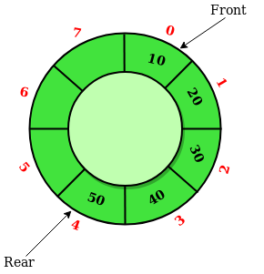 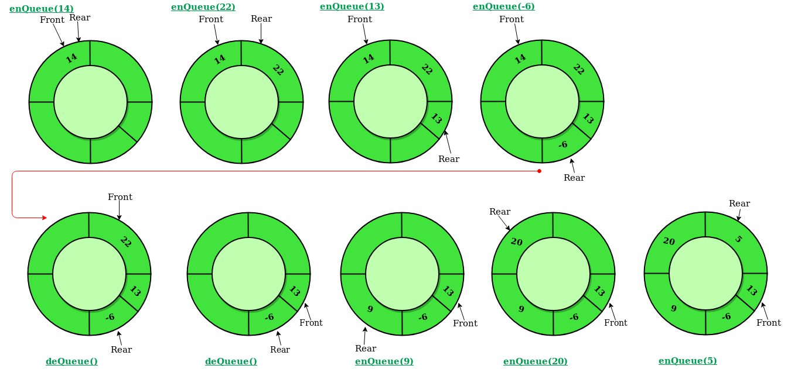

**int empty(que *q)**

{

if(q->front == -1 && q->rear == -1) return 1 ;

else return 0 ;

}

**int full(que *q)**

{

if(q->front == 0 && q->rear == MAX -1 || q->front = q->rear+1) return 1;

else return 0 ;

}

**int peek(que *q)**

{

if(empty(q)) return -9999;

else return q->arr[q->front];

}

**void** **enQue(que *q , int n)**

{

if(full(q))

{

printf(“OVERFLOW\n”);

return ;

}

if(empty(q))

{

q->front = q->rear = 0 ;

}

else if(q->rear == MAX-1) q->rear = 0 ;

else q->rear++ ;

q->arr[q->rear] = n ;

}

**void deQue(que *q)**

{

if(empty(q))

{

printf(“UNDERFLOW\n”);

return ;

}

if(q->front == q->rear)

{

q->front = q->rear = -1 ;

}

else if(q->front == MAX-1) q->front = 0 ;

else q->front++ ;

return ;

}

**Singly Linkedlist Implementation**

Drawbacks of a sequential(array) representation of a queue data structure:-

- Finite capacity of queue

- Checking for Overflow condition every time an enQue() operation is done .

**typedef struct node{**

**int info ;**

**struct node *next ;**

**}nod;**

**int main()**

**{**

**nod *front , *rear ;**

**front = rear = NULL ;**

**enQue(&front , &rear , 10);**

**enQue(&front , &rear , 8);**

**enQue(&front , &rear , 5) ;**

**deQue(&front , &rear);**

**printf(“%d”,peek(front));**

**}**

**void enQue(nod **f, nod **r , int n)**

{

nod *newnode = (nod*)malloc(sizeof(nod));

newnode->info = n ;

newnode->next = NULL ;

if(*f == NULL)

{

*f = newnode ;

*r = newnode ;

}

else

{

*rear->next = newnode;

*rear = newnode ;

}

return ;

}

**void deQue(nod **f , nod **r)**

{

if(*f == NULL)

{

printf(“UNDERFLOW\n”);

return ;

}

nod *temp = *f ;

*f = *f->next ;

temp->next = NULL;

if(temp == *r) *r = NULL;

free(temp);

return ;

}

**int peek(nod *f)**

{  
 if(f==NULL) return -9999 ;

return f->info ;

}

Deque

- It has O(1) complexity for all the operations

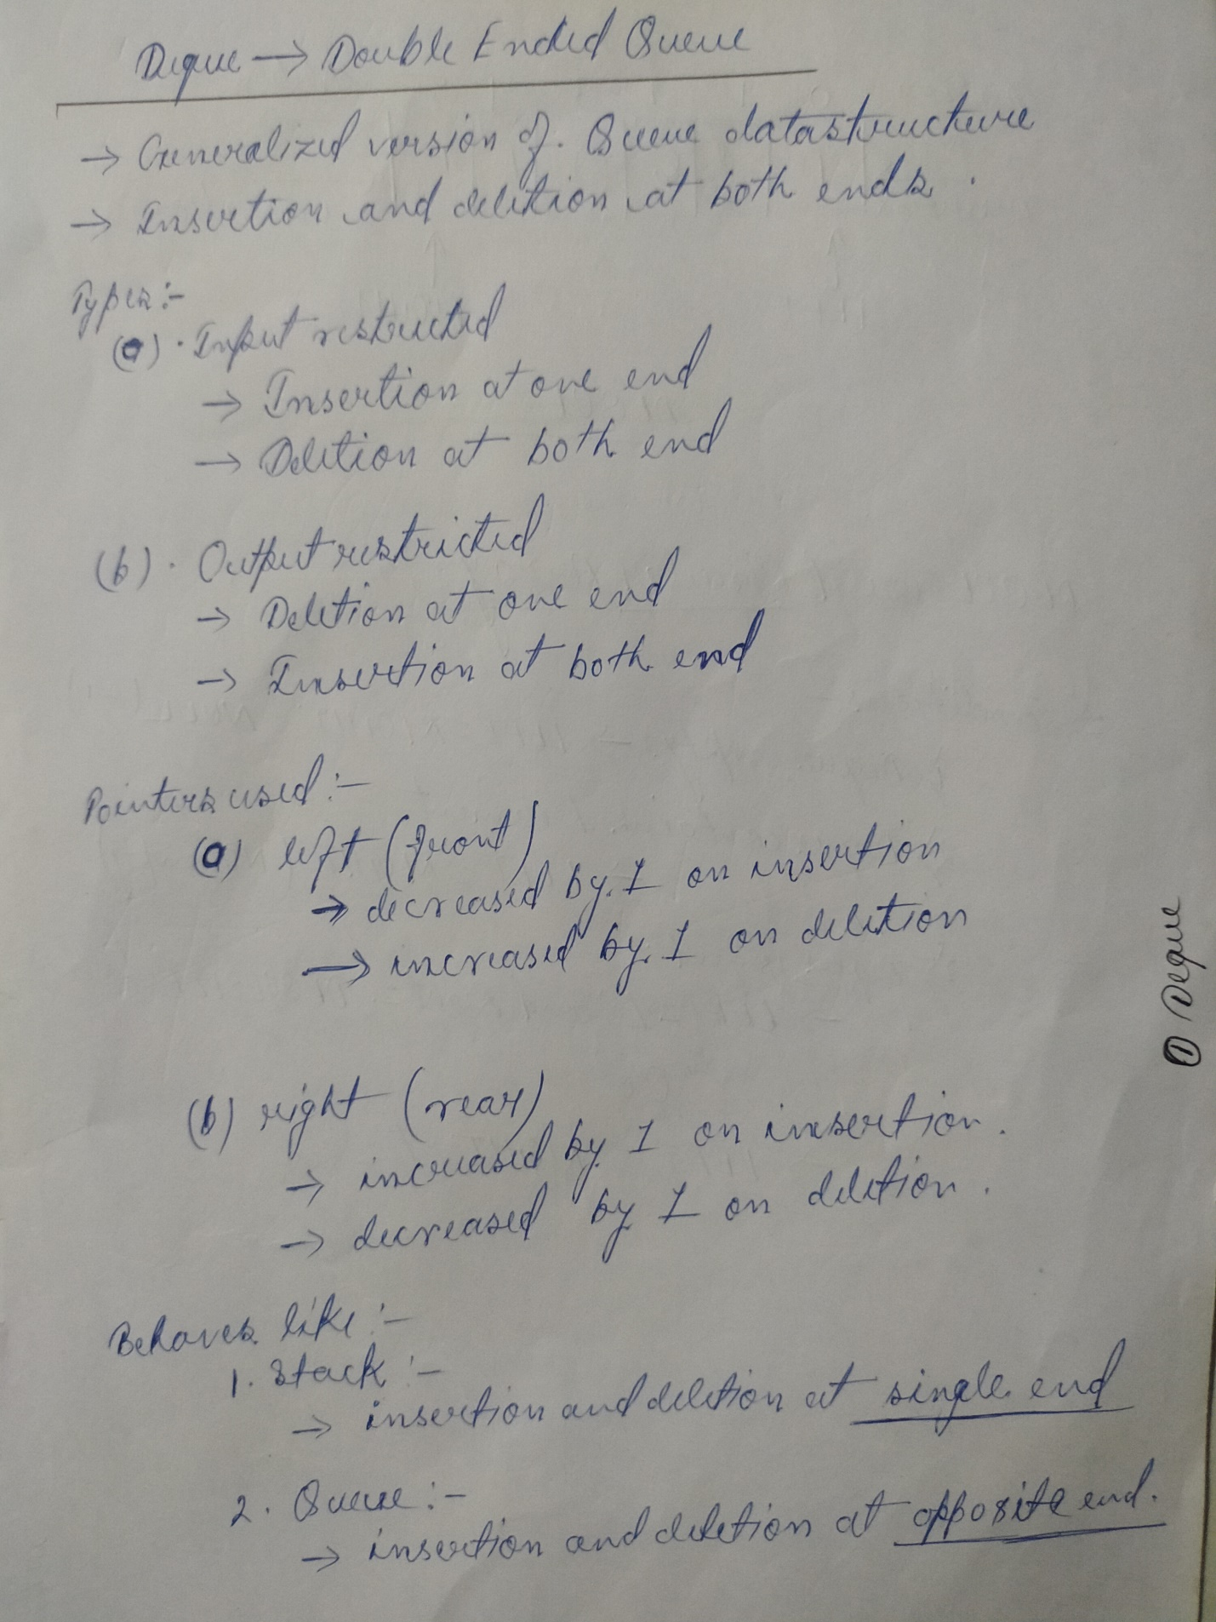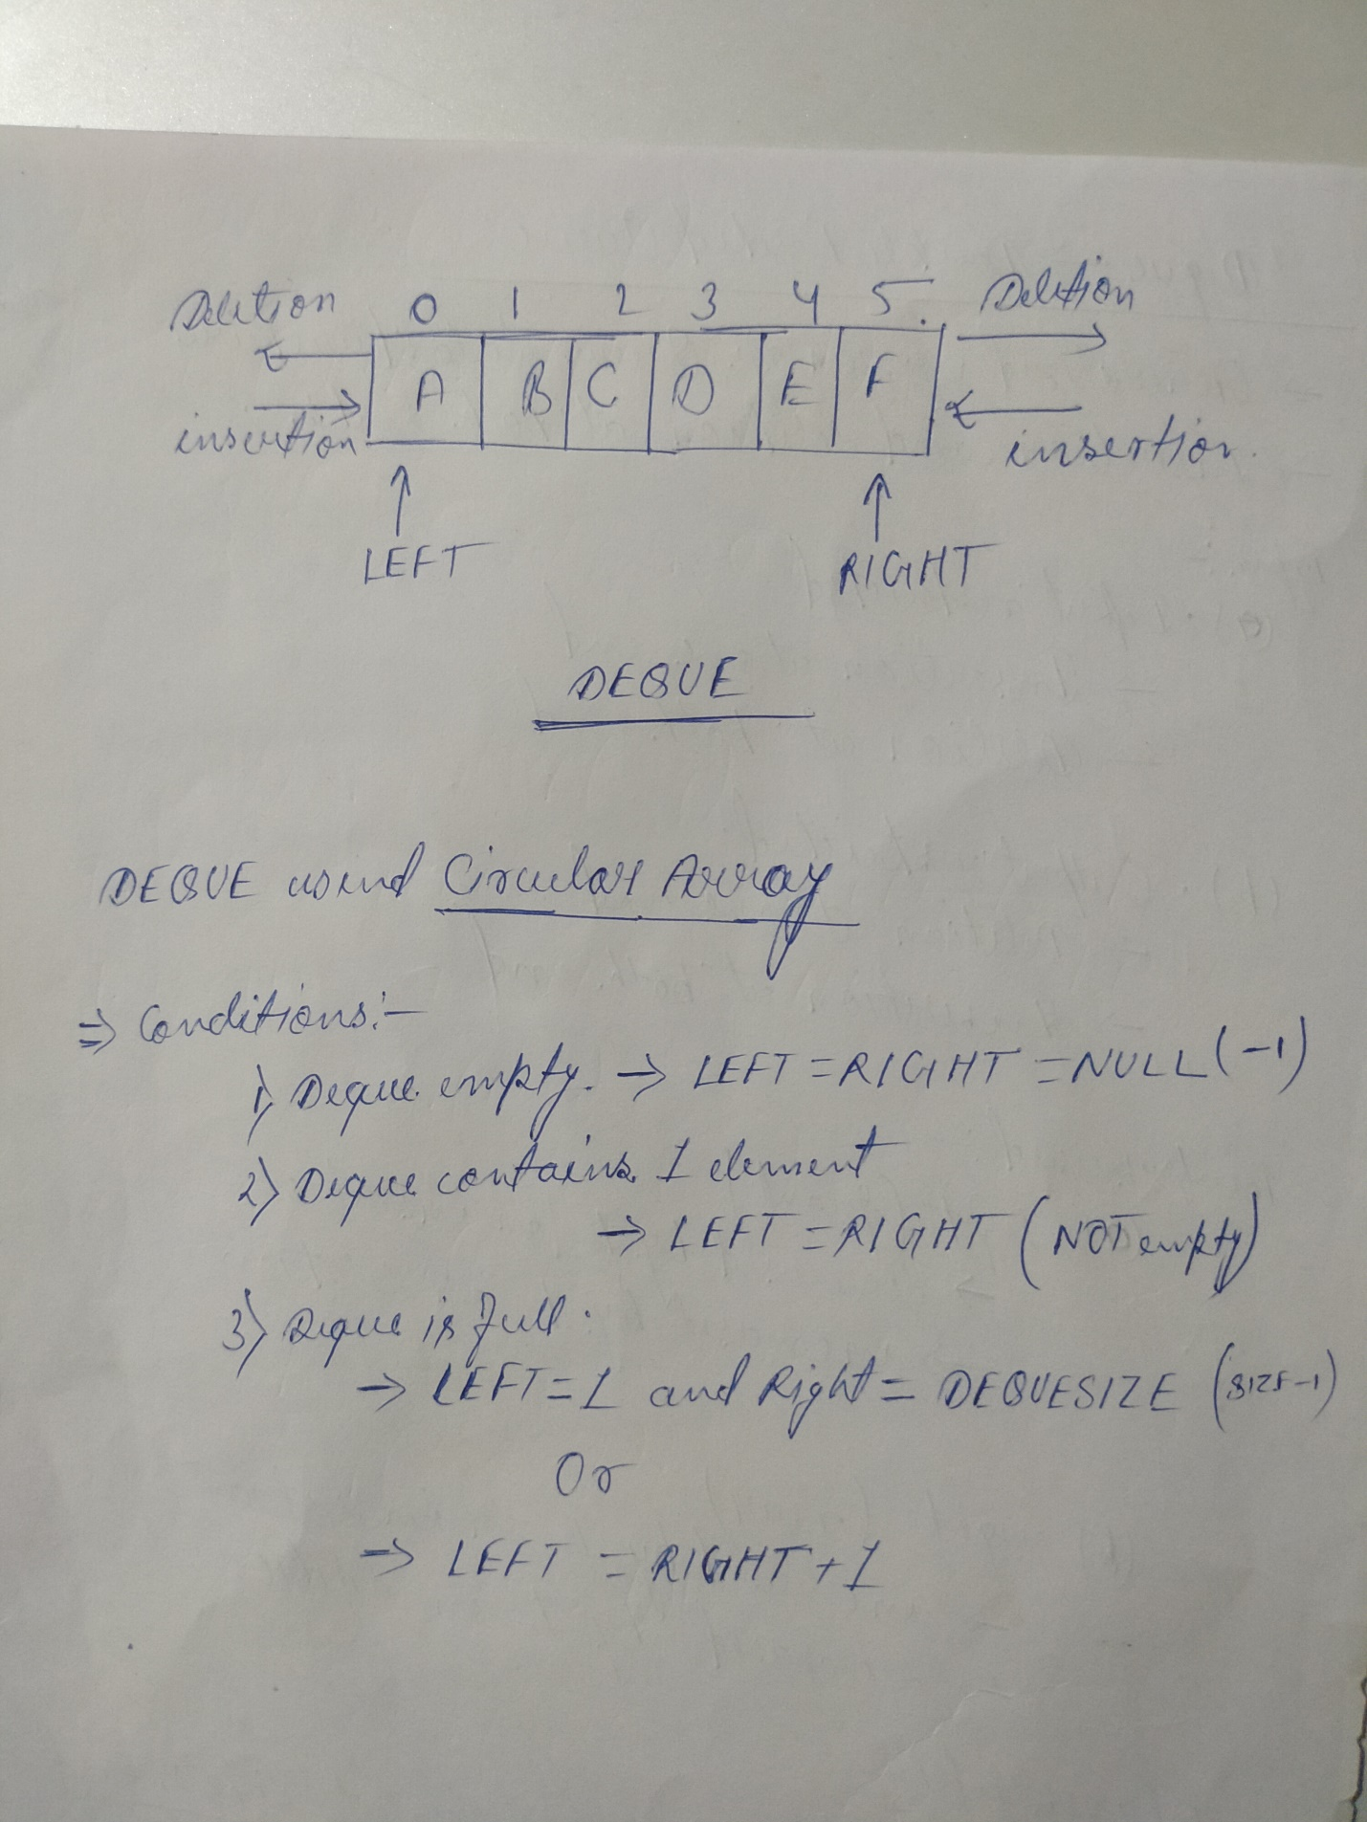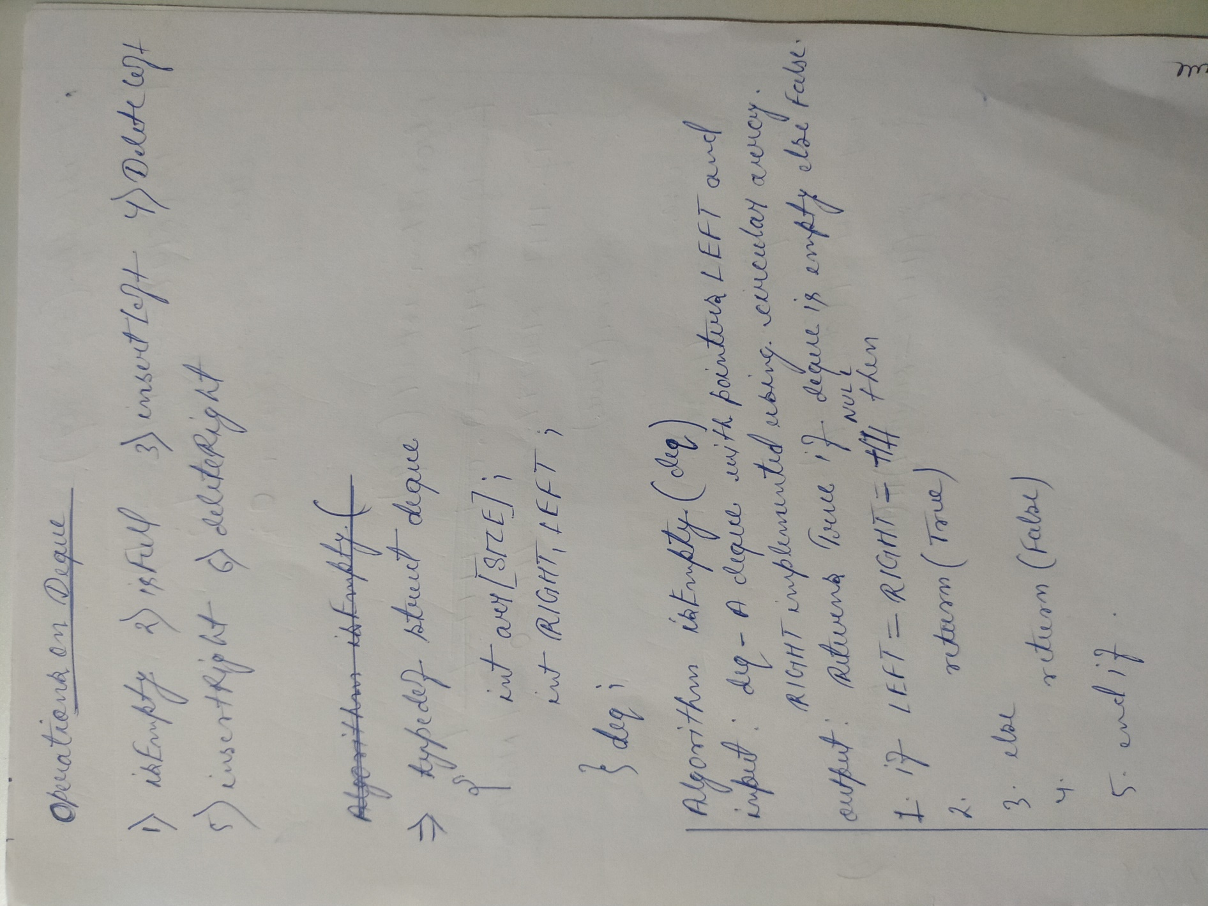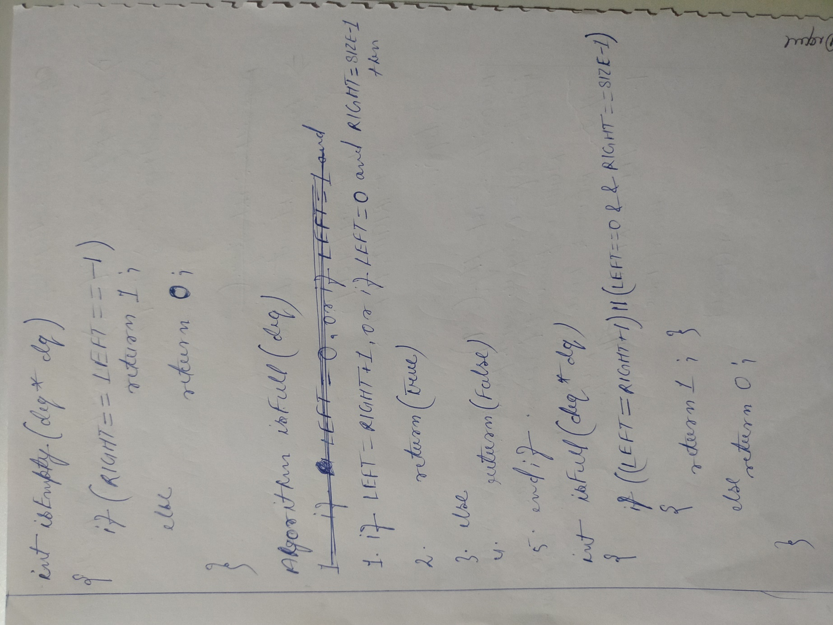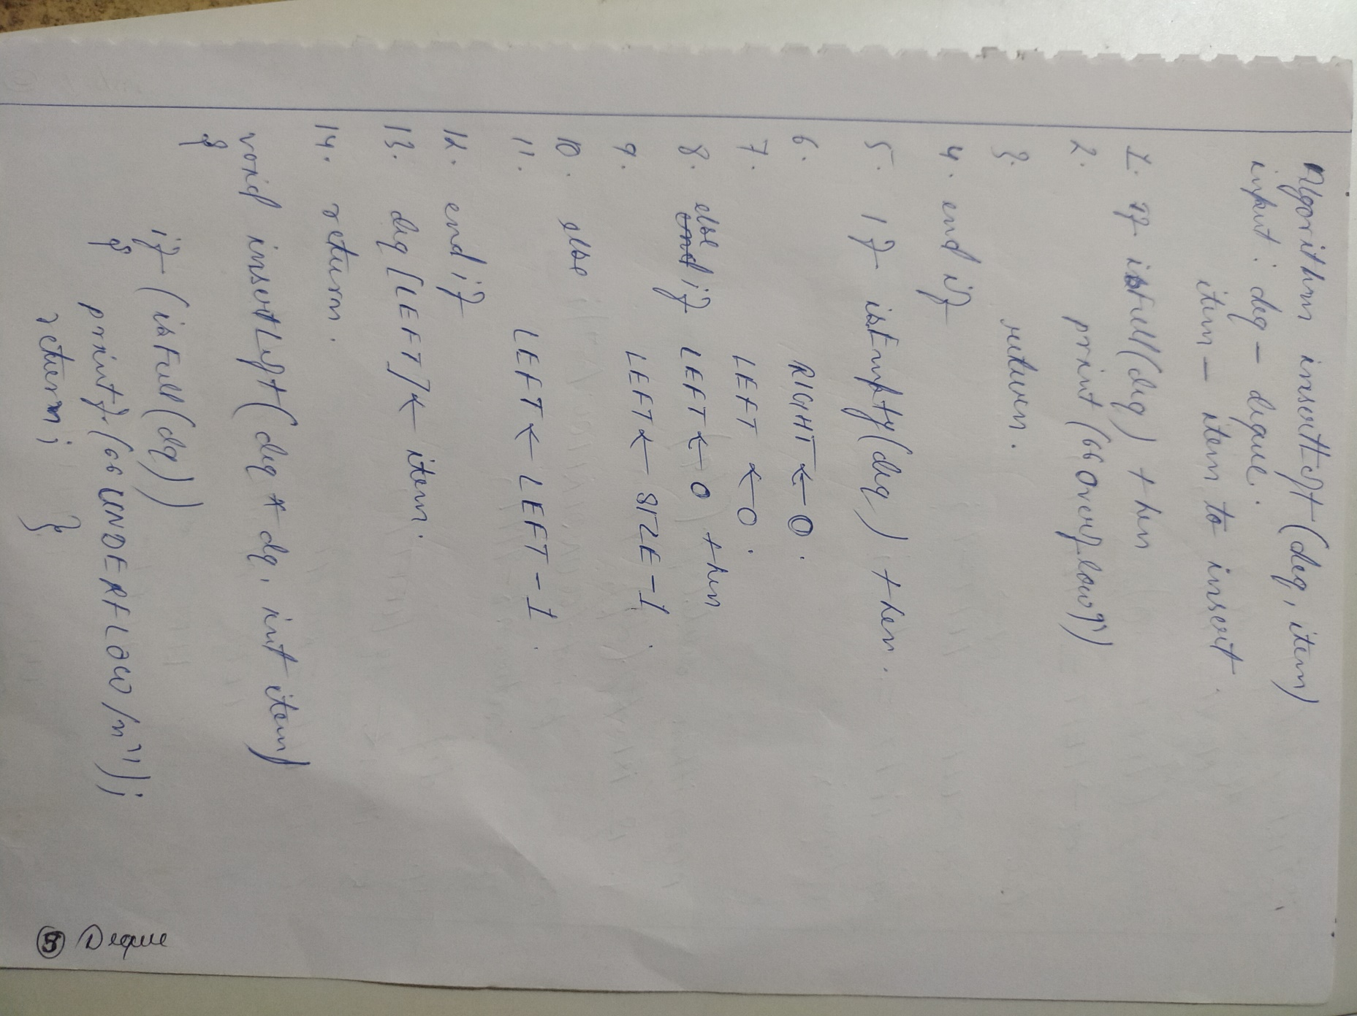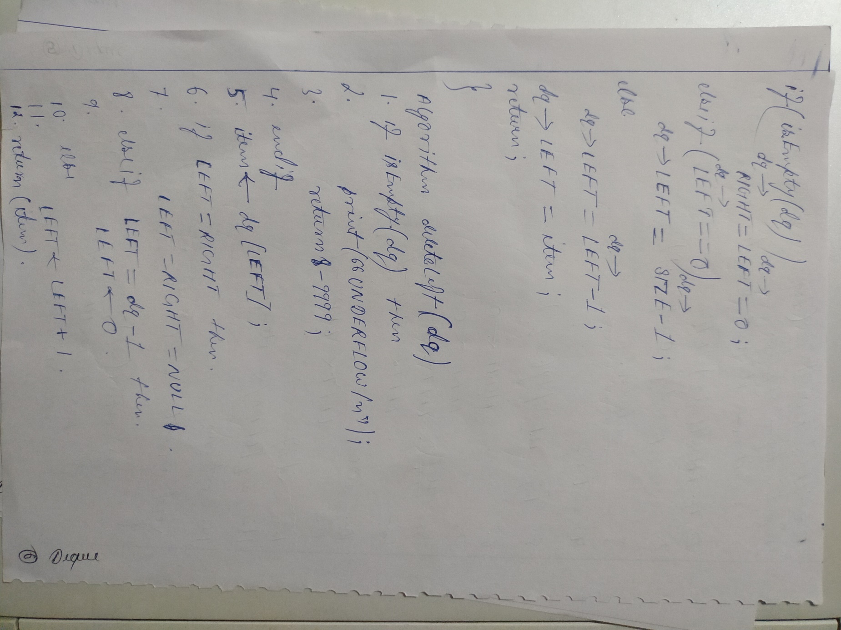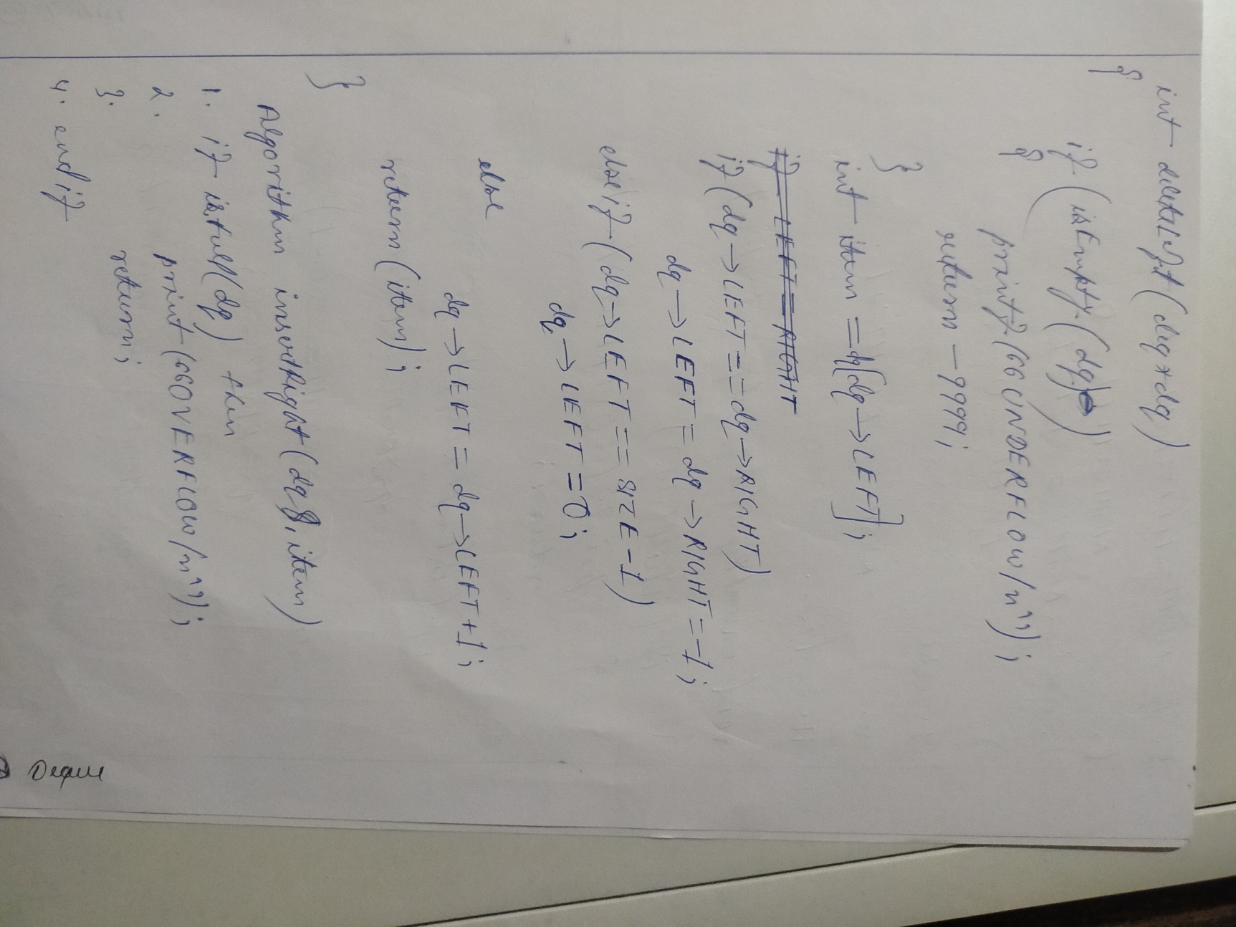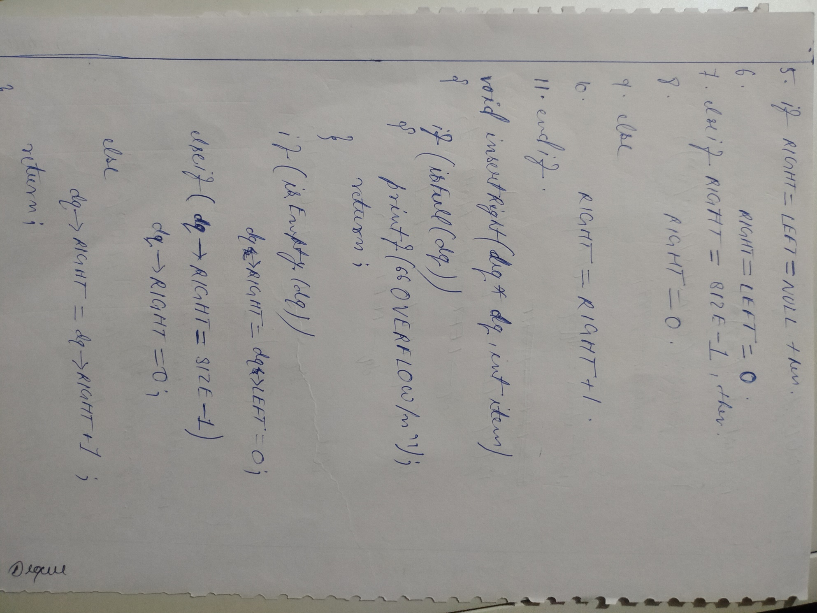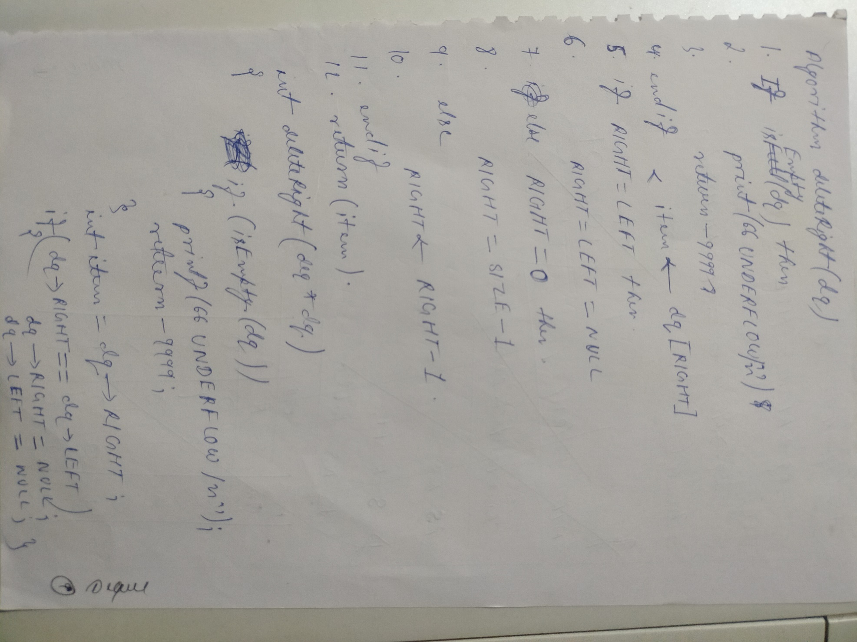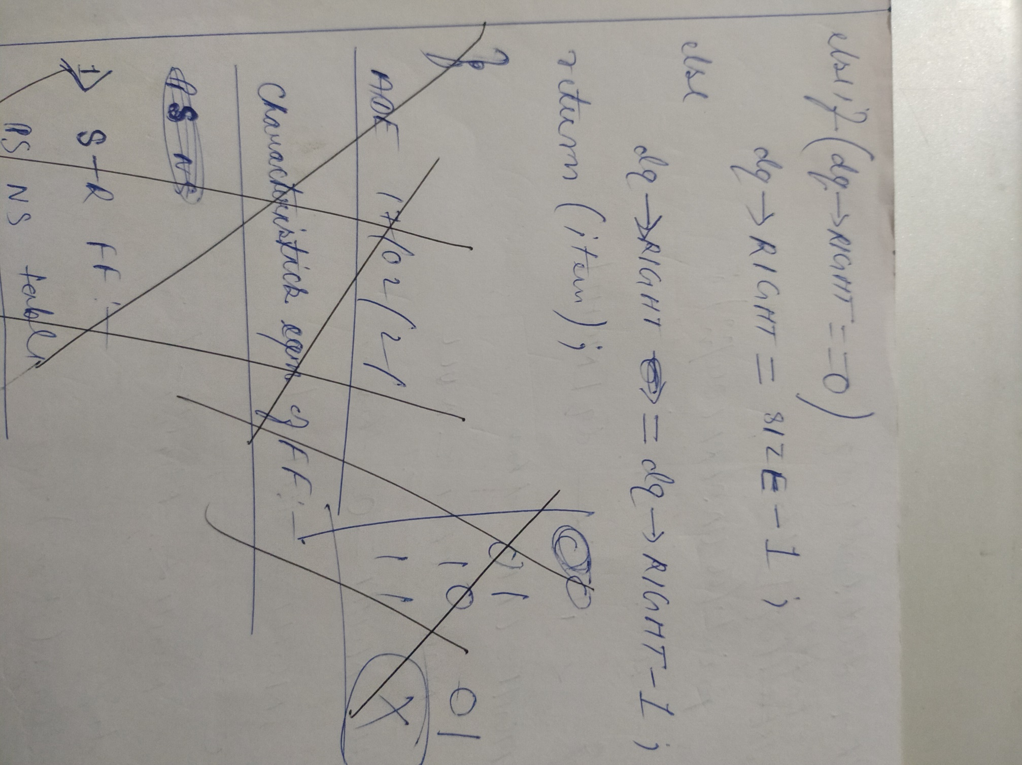

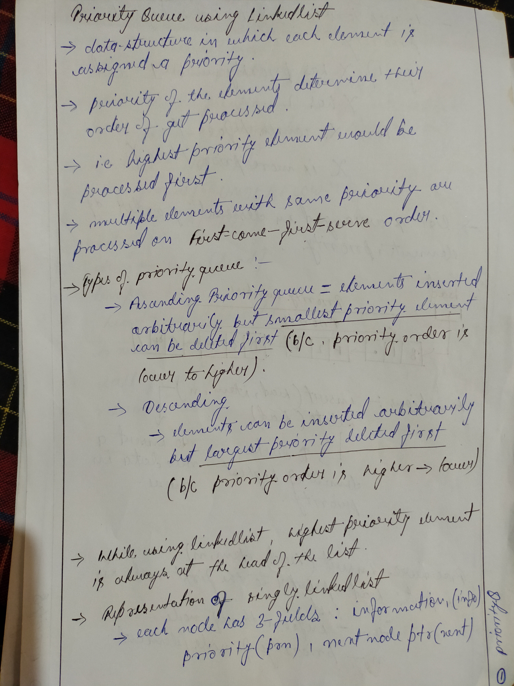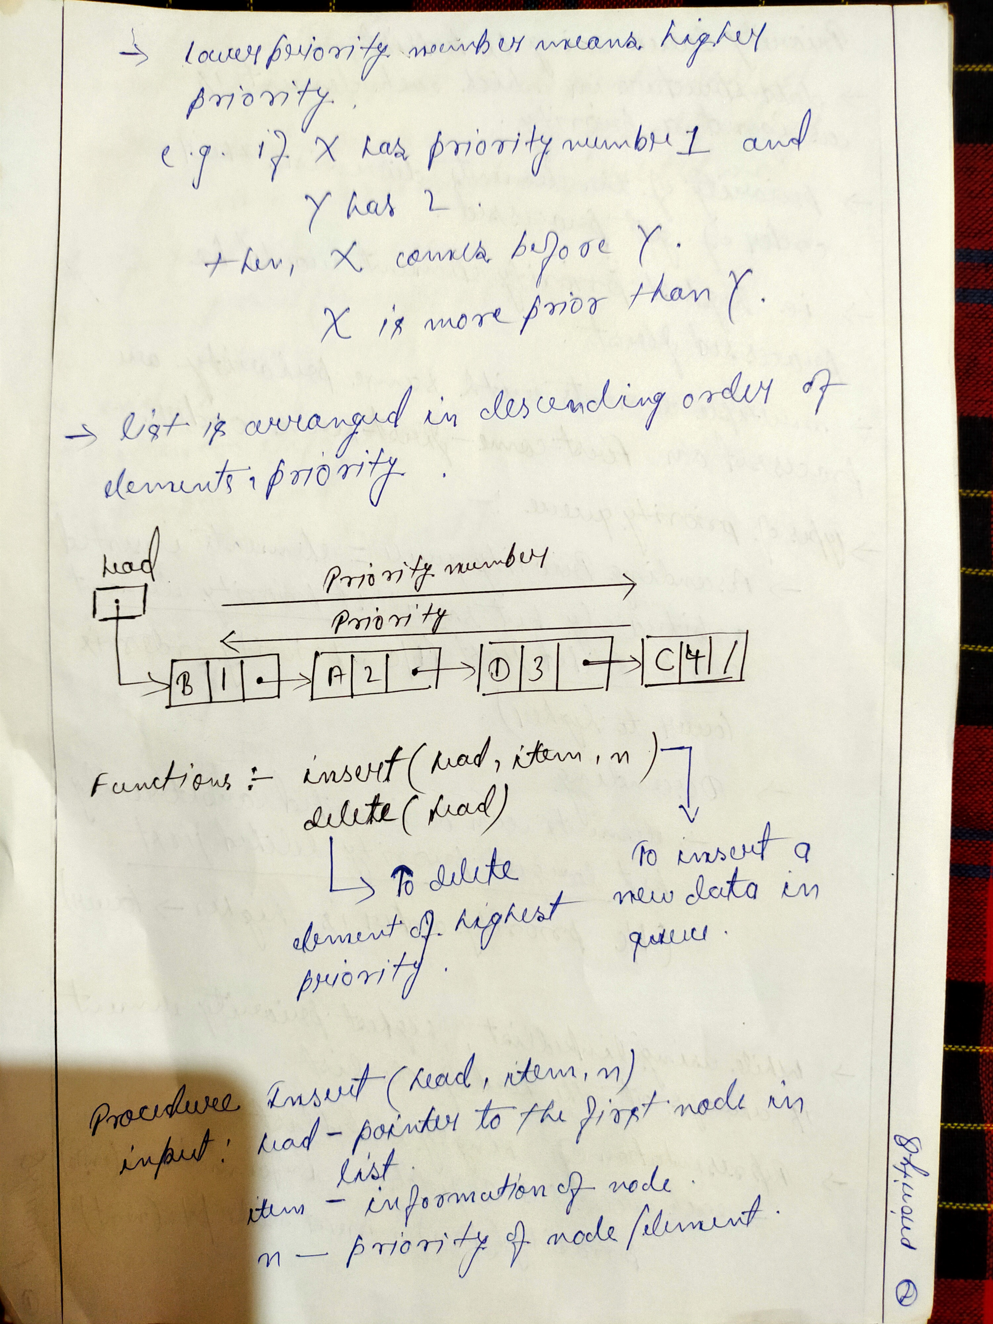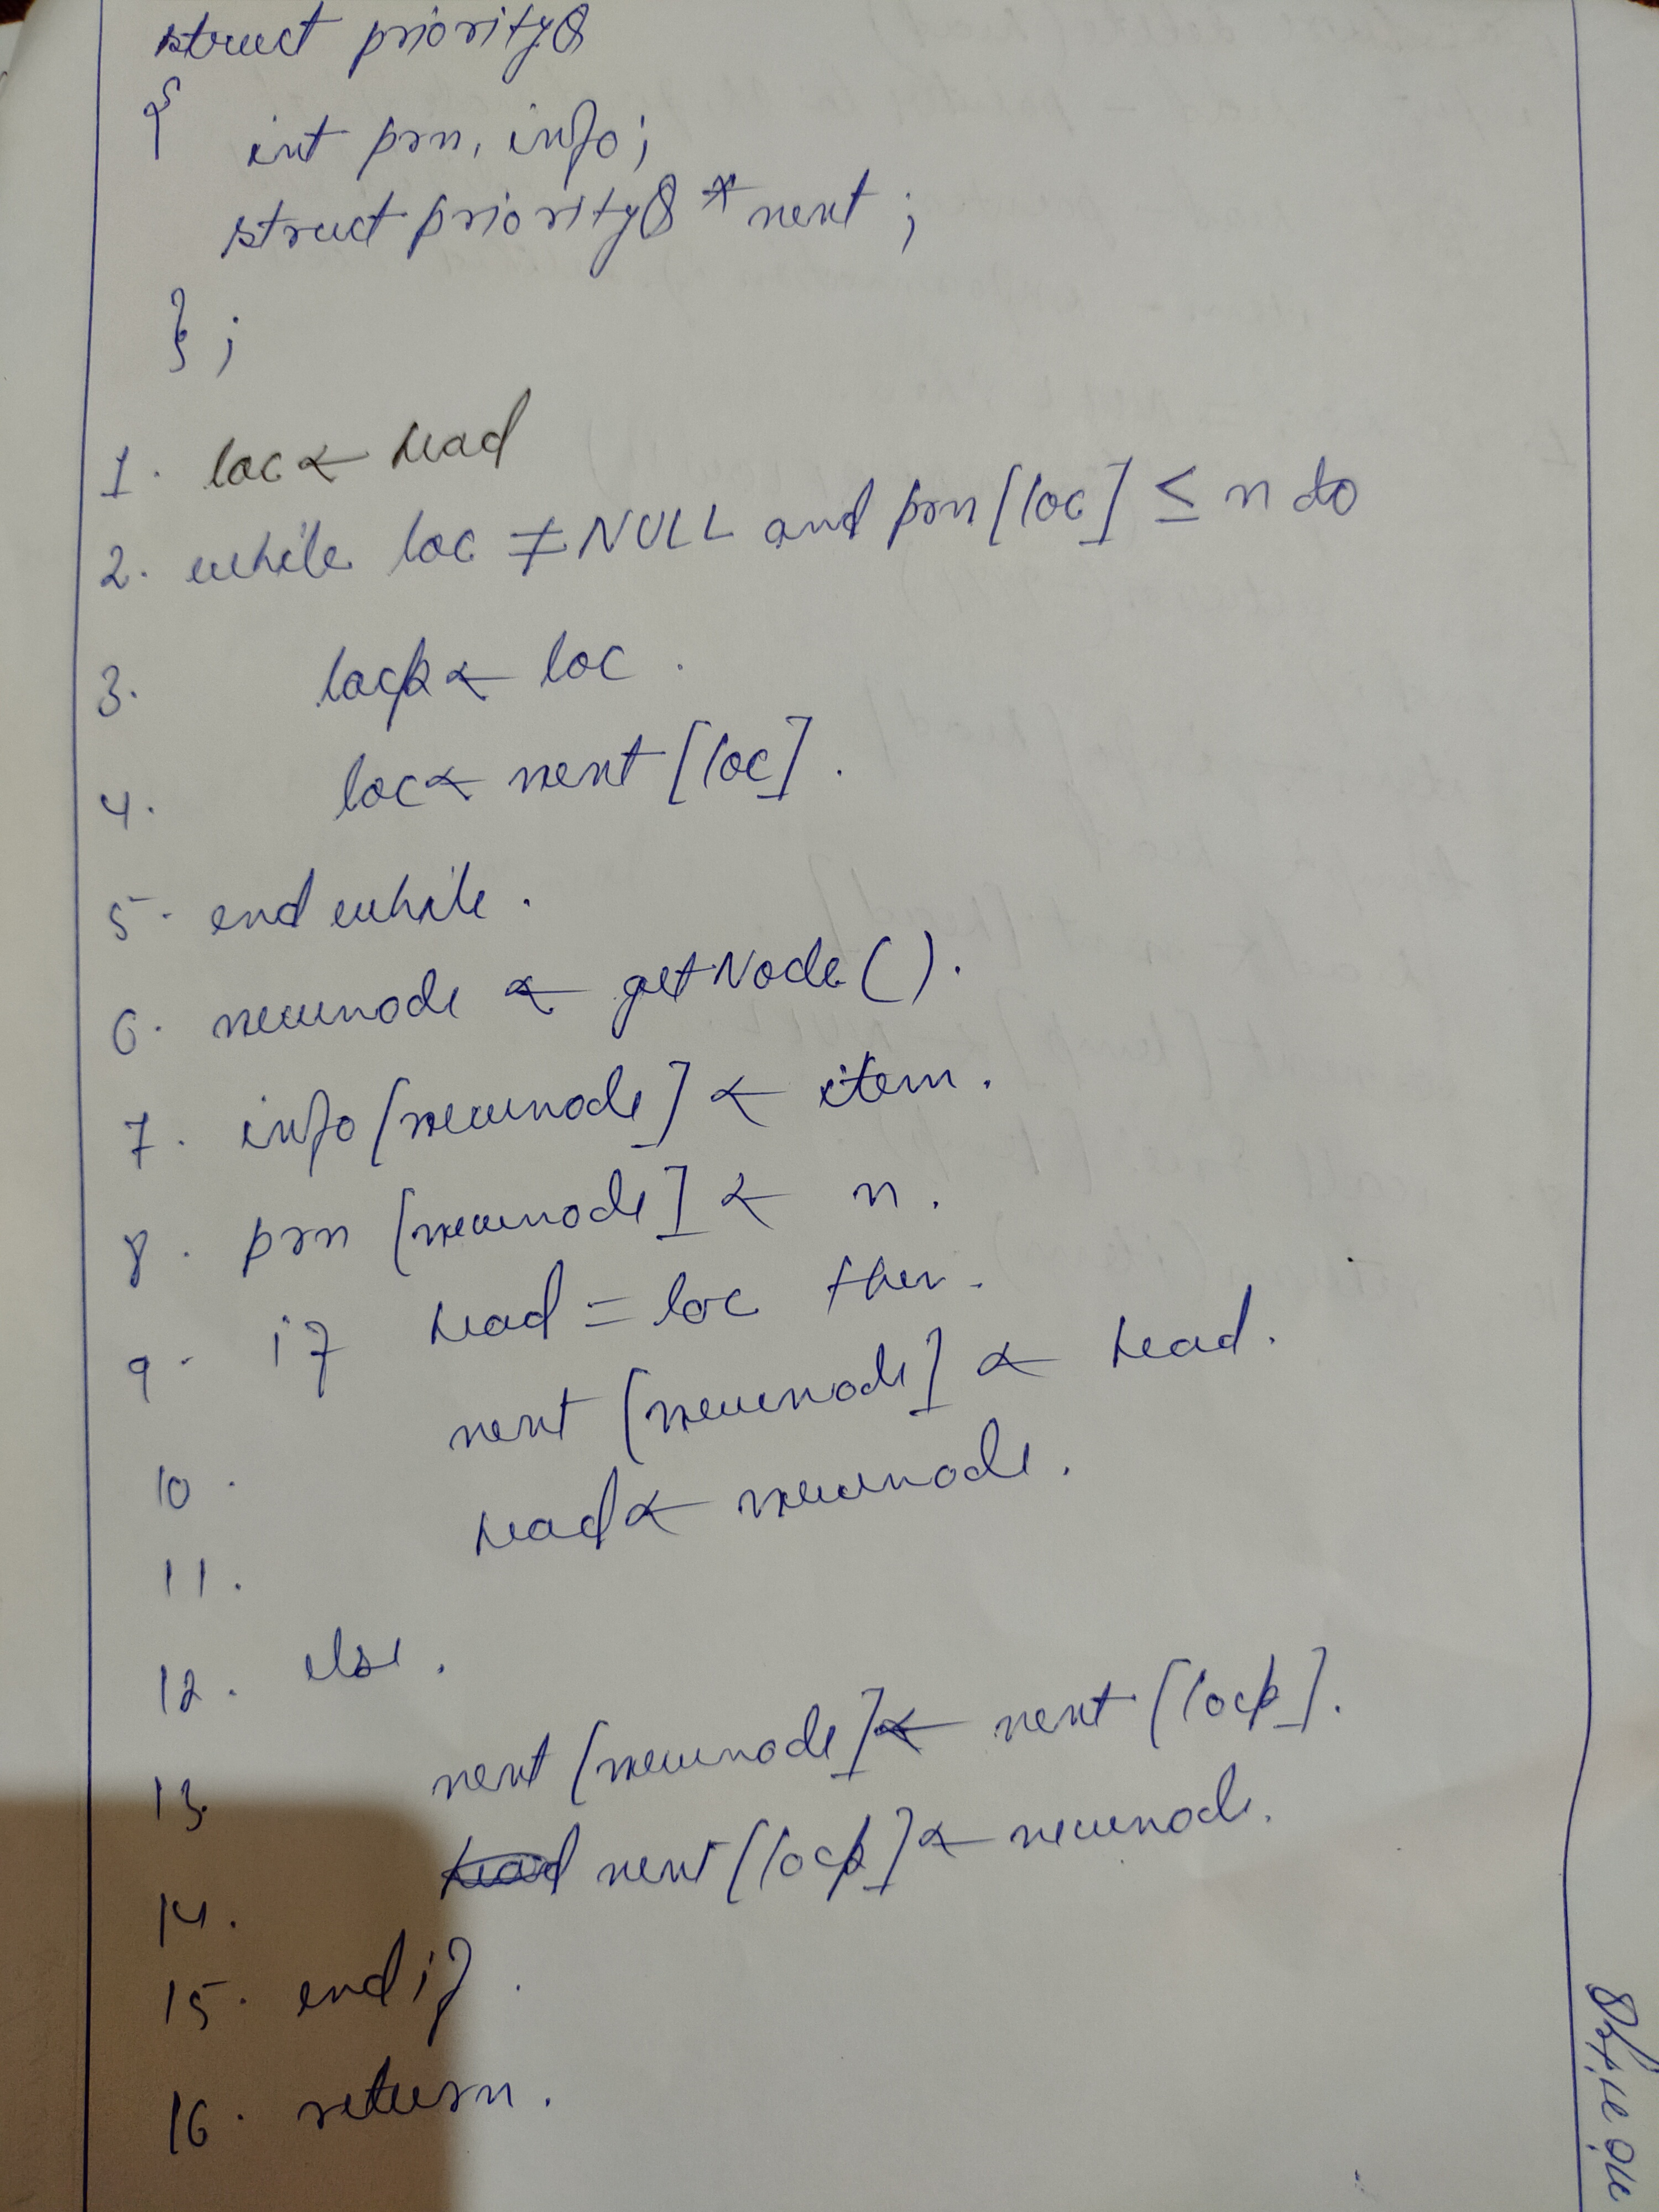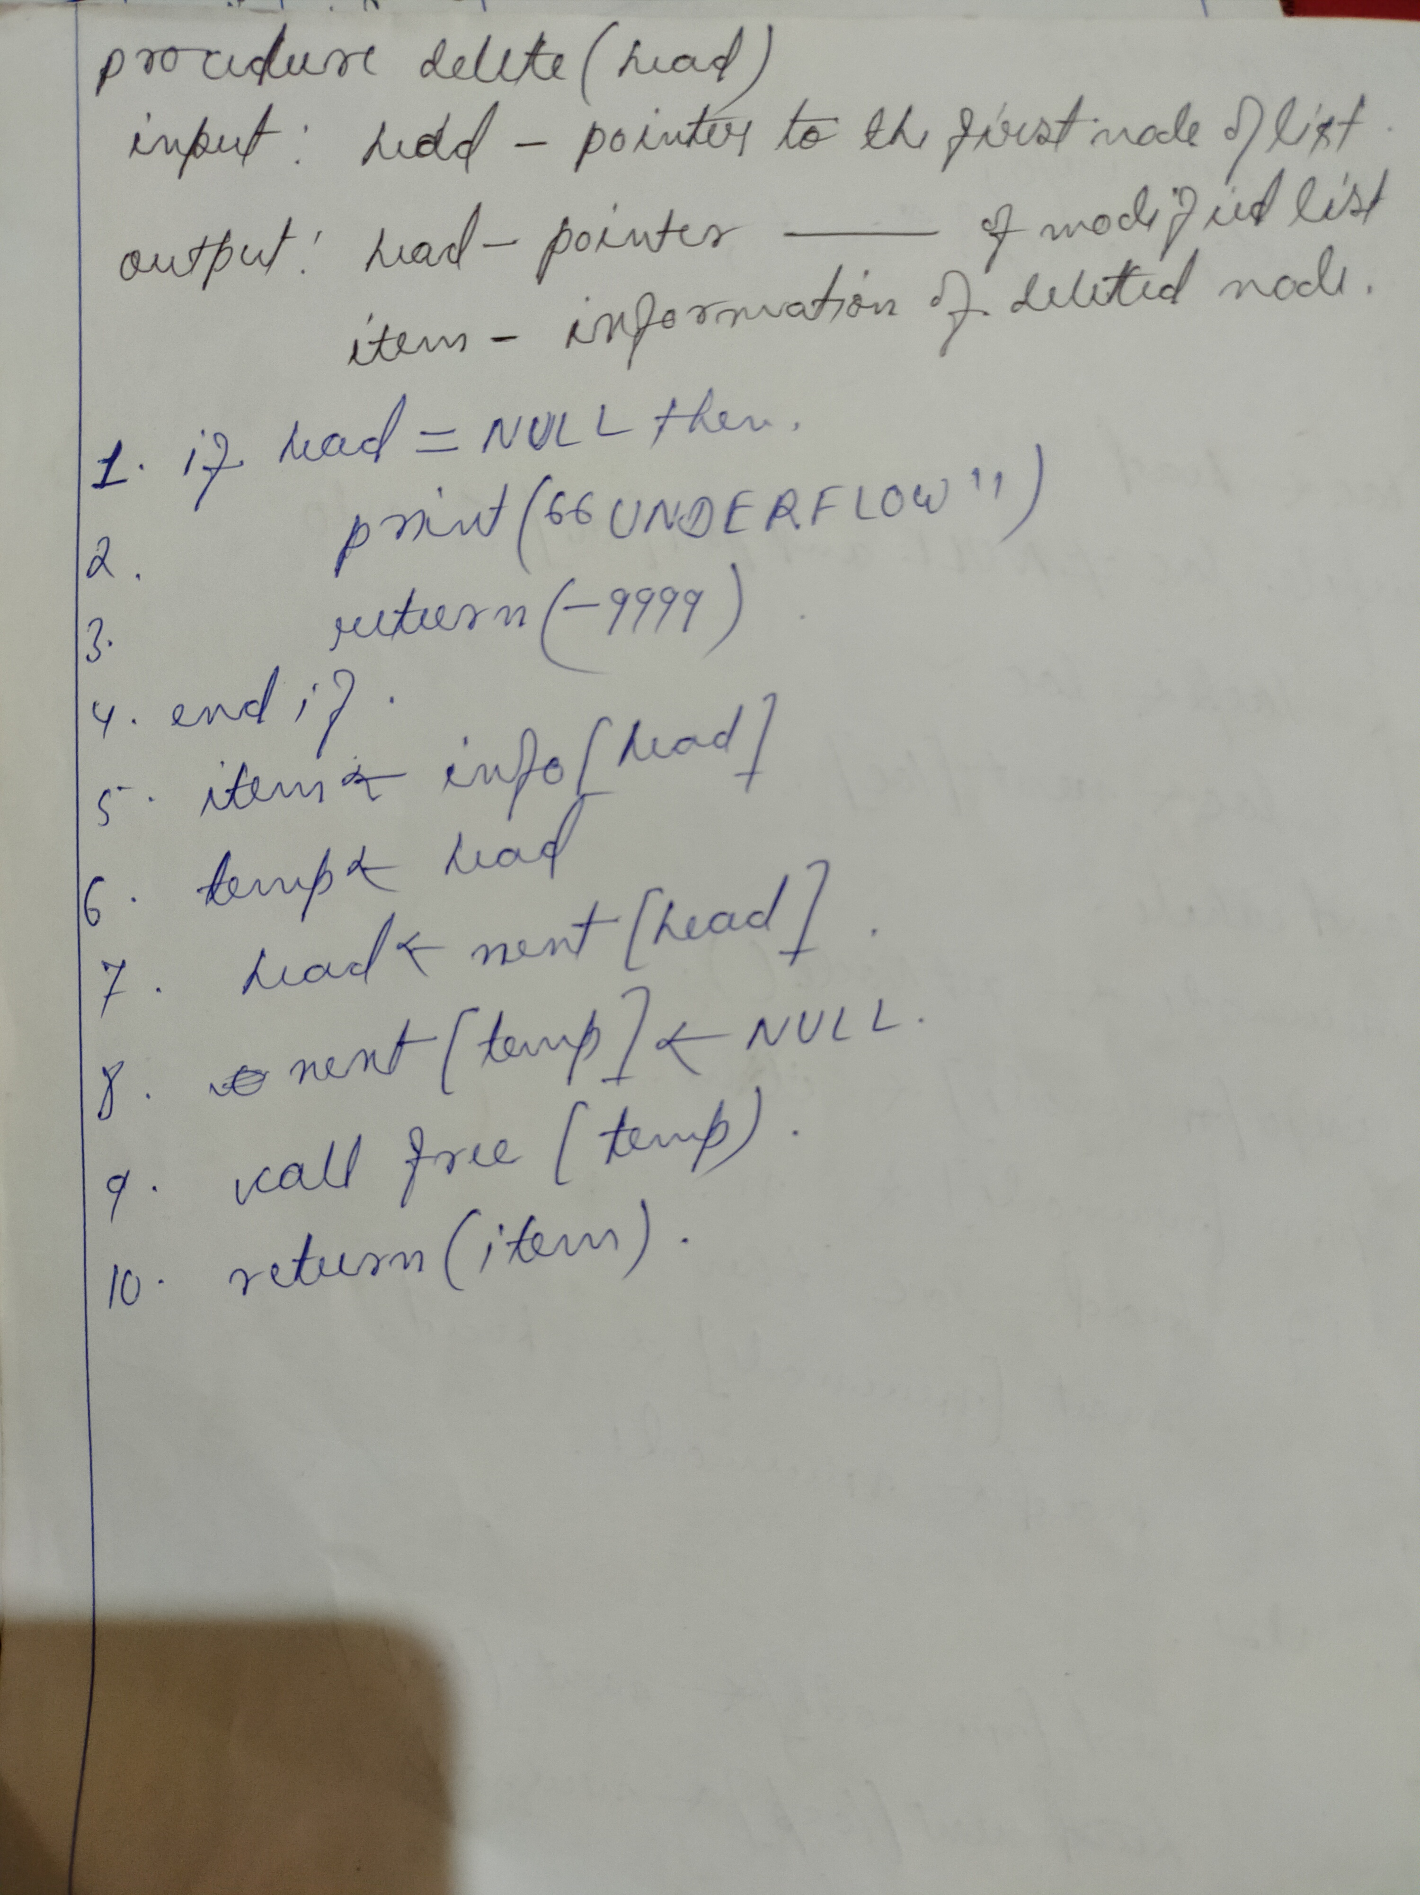

**- Priority queue has O(1) complexity for enqueue() operations , O(n) for dequeue() and for peek() operations**

**Trees**

- A tree is a finite set of nodes , such that there is a specially designated node called root of the tree

- It is a non-linear data-structure and hence there exist a hierarchial relationship between its elements

- Trees and Graphs are the non-linear data-structure , Ex:-

Book

C1 C2 C3

S1.1 S1.2 S2.1 S2.2 S2.3

S2.1.1 S2.1.2

Book

Chapter1

S1.1

S1.2

Chapter2

S2

S2.1.1

S2.1.2

S2

Chapter 3

Applications:-

1 . Directory structure in OS

2 . Used to organize informations in Databases Systems

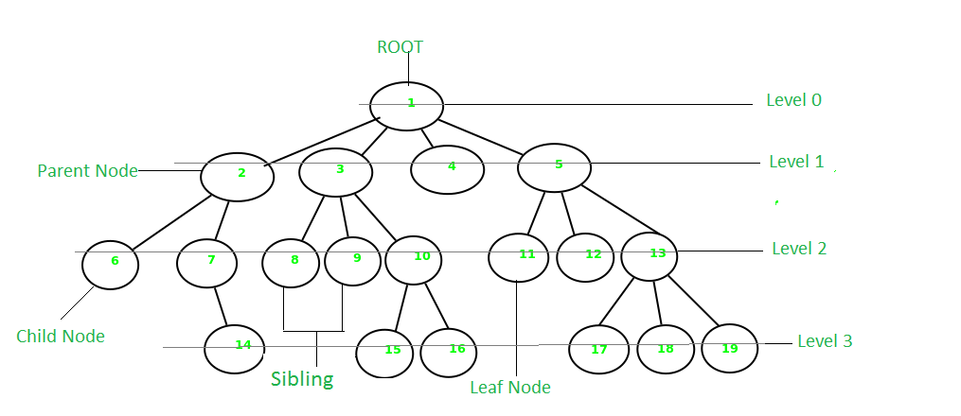

Some key points:-

- A tree data structure is defined as a collection of objects or entities known as nodes that are linked together to represent or simulate hierarchy

- It is a non-linear data structure because it doesn’t store elements in a sequential manner .

- It is a hierarchical structure as elements in a Tree are arranged in multiple levels

- topmost node is called root .

- Each node contains some data , and data can be of any type i.e string , int etc.

- Each node contains some data and the link or reference of other nodes that are called children

**Some tree Terminologies:-**

**root** : the topmost node . It doesn’t have any parent . ex: 1

**child node** : descendant of any node : 2 , 3 , 4 etc

**parent** : having any sub-node . ex:- 2 , 3 , 5 etc

**sibling** : nodes that have the same parent . ex:- 2,3,4,5 etc

**leaf/external-node** : node with no children . ex: - 14 , 15 , 16 . 11 etc

**non-leaf/internal** : node with at least one child . ex:- 7 , 10 etc

- root node has level 0

- level of any other node is one more than the level of its parent

- Depth(height) of a tree is the **maximum level of any leaf node** in the tree

- Thus the height equals the length of the longest path from root to any leaf node

- Degree of a node in a tree is determined by the **number of its children** like , 1 is degree-4 , 2 is degree-2 and so on

- A node or vertex carries information

-A link b/w parent and its child is called **edge**

- If there are n nodes, then number of edges = **n-1**